the Internet Bookstore’s Log In use case

this system bring user to sign on page, by click sign on button, take user to the sign on page

The user types an email address, the desired password, and clicks on “Sign on”. The system checks that the user has typed valid information into the email and password boxes, and takes the user to the home page.

Email: user has to type the email used for sign up the account, if did not type anything inside the type box, will have a reminder text for user to type somethings in.

Password: user has to type the correct password, which has to match with the Email when user sign up.

Sign on: when trigger the sign on button with all the information correct will take user to another page.

Privacy Policy: will take user to privacy policy’s page

Terms & conditions: will take user to terms & conditions page

Details: will show user the detail of keep me signed in.

Forgot the password: when triggered, will send a verify email to email with a link to reset the password.

Forgot the password: User type the email used for signed up the account. Type characters from the image above. Click the continue button to trigger a request to send an email to the email that user used.

See a new challenge: will change the image to another random character.

Hear the challenge: this function will transform the image to sounds.

Having trouble or sight impaired: will pull out another page.

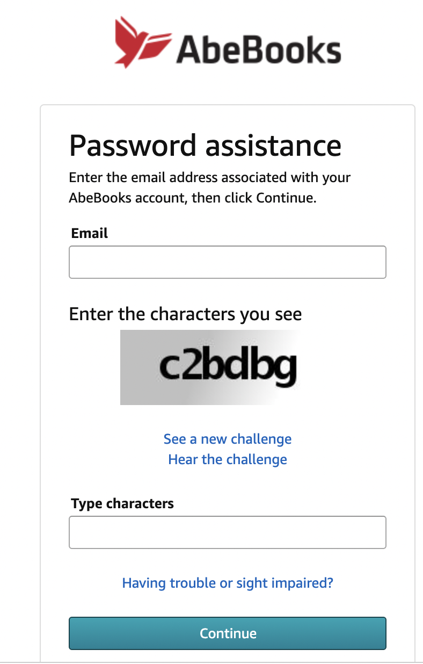

If the user clicks on Privacy Policy, the system shows the user abebooks.com’s privacy policy.

Terms&conditions If the user clicks on terms&conditions, the system shows the user abebooks.com’s terms and conditions.

Keep me signed in: Details: click here will pull up the details about keep me sign In checkbox.

